LEGALLY REQUIRED OFFICIAL POSTING – PLEASE DO NOT REMOVE UNTIL AFTER BELOW DATE AND TIME

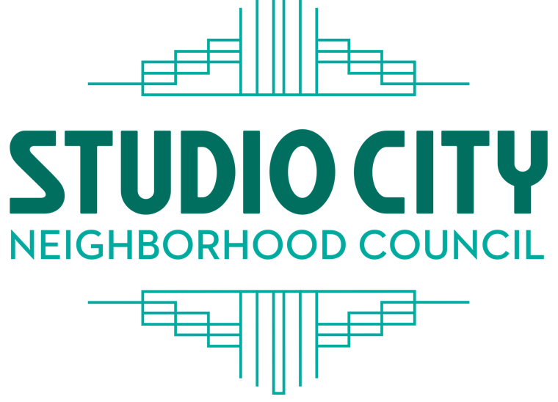
SCNC BOARD |  | PRESIDENT
 |  | Jerry Lewis
Merci Borden |  | VICE PRESIDENT
Kesara Borirak |  | Jeff Hartwick
Victoria Brown |  | TREASURER
Kim Clements |  | Kim Clements
Dean Cutler |  | SECRETARY
Andrew Epstein |  | Jay Friedman
Jay Friedman |  | CORRESPONDING
Daniel Fuselier  Lusine Galadjian  Dimitri Gatsiounis  Jeff Hartwick |  | SECRETARY  Dimitri Gatsiounis
Jerry Lewis
Richard Niederberg
Laurie Rittenberg
Matt Thompson
 |  | studiocitync.org

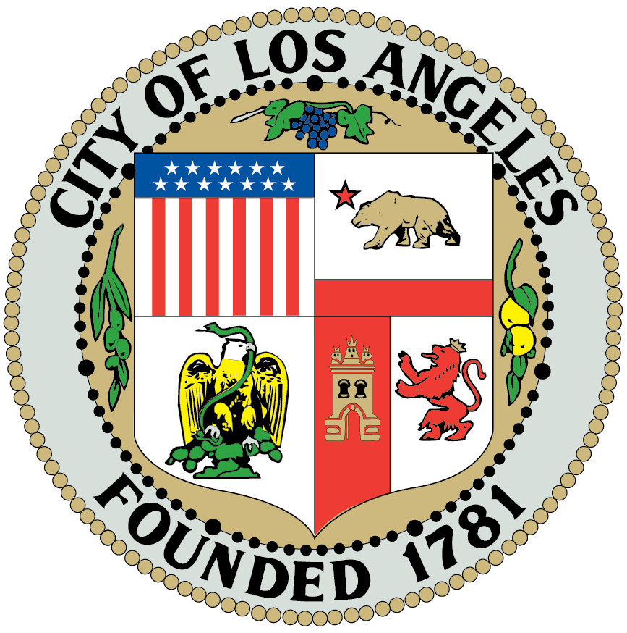

CULTURAL AFFAIRS COMMITTEE MEETING

AGENDA
July 16, 2026 @ 7:00 PM

4024 Radford Avenue, Editorial 2, Room 6
Studio City, CA 91604 (818) 655-5400

Please use RADFORD GATE (4024 Radford, just north of Ventura
Blvd). Use the drive on or pedestrian access and follow
instructions from Radford Security

Stakeholders with disabilities who have a valid DMV placard, use a wheelchair, walker or cane, and/or those who have difficulties walking distances should notify a Radford Studio Center Security Officer or call 818-655-5085 to request shuttle assistance.

Committee Members:
Committee Members: Abi Velasco (Chair, Stakeholder), Merci Borden (Vice Chair, Board Member), Barry Johnson (Stakeholder), Mary Mallory (Stakeholder), Christine From (Stakeholder), and Jerry Lewis (President Ex-Officio).

- Call to Order & Roll Call
Name | Yes | No
Abi Velasco | X
Barry Johnson | X
Merci Borden | X
Mary Mallory |  | X
Christine From | X
Lusine Galadjian | X

- Approve minutes for April 2026: Minutes will be approved in August 2026.
Name | Yes | No
Abi Velasco
Barry Johnson
Merci Borden
Mary Mallory
Christine From

- Announcement from Committee Chair and Vice Chair.
Welcome Merci as the Vice Chair for Cultural Affairs.
Merci kindly accepted the position.

- Public Comment on non-agenda items within the committee’s jurisdiction (1 min per speaker extendable by Chair, 5-min maximum extendable by chair).
A member of the public expressed concerns regarding whether individuals with criminal histories are permitted to participate in committee activities or Neighborhood Council functions. The comments included references to specific past cases but did not result in a formal request for action.
Another member of the public suggested that certain committees, including Cultural Affairs, consider holding meetings via Zoom rather than in person. The speaker noted that other committees (Budget, Outreach, Sustainability) have transitioned to virtual meetings with increased public participation. They also mentioned that in-person meetings present logistical challenges, including travel time and parking, and that attendance at the current meeting was minimal.

- Discussion- Recap- Movies in the park, June 2026, Abi Velasco.
The committee discussed the Movies in the Park event held in June 2026. Members reported a strong turnout, though an exact attendance count was difficult due to families and children moving between the playground and event area. The President expressed that at least 200 stakeholders showed up to the event. Overall, the event space remained consistently full, and attendees included families from Studio City and surrounding neighborhoods.
Committee members noted that the selected park was a significantly better venue than previous locations, offering improved space and accessibility. The event also helped increase Neighborhood Council visibility among families who were not previously familiar with the council’s role. Several attendees expressed interest in future involvement, including potential board participation. Resource tables were available, and members observed that the public benefited from the information provided.
Questions were raised regarding Toluca Lake Neighborhood Council’s anticipated financial contribution. Although Toluca Lake had initially expressed interest in co-sponsoring the event and provided a verbal commitment, no payment was received. Members clarified that:
- Toluca Lake’s contribution was never part of the official Movies in the Park budget approved by the SCNC board.
- Miscommunication occurred due to changes in the Budget Committee chair and unclear processes regarding invoicing.
- The Neighborhood Council cannot generate invoices, and coordination with the City Clerk would have been required.
- Toluca Lake promoted the event minimally, and it is unclear how many attendees came from that area.
- A member asked whether there is a standard procedure or template for collecting funds from partner Neighborhood Councils. It was clarified that Neighborhood Councils do not collect money directly, and this situation was unusual. There is no existing template or standardized process for handling such contributions.
- It was noted that only the Treasurer or the President can communicate with the City Clerk, as the Clerk will not provide guidance to other board members. In similar cases, the City Clerk would need to advise the officers on the correct procedure for processing contributions or reimbursements. The discussion indicated that clearer coordination and communication would be necessary in future partnership events to avoid misunderstandings.
- The committee discussed whether Toluca Lake might apply its previously discussed contribution toward a future co-sponsored event. Further clarification from Toluca Lake and the SCNC Treasurer would be needed.
The committee discussed the intended partnership between the Studio City Neighborhood Council (SCNC) and the Greater Toluca Lake Neighborhood Council (GTLNC) for the Movies in the Park event. Members noted that the collaboration was well-intended, but the financial contribution originally discussed did not materialize due to budget-related misunderstandings.
It was clarified that:
- GTLNC had verbally committed at GTLNC Board meeting to contributing $1,500 toward the event.
- Both councils were unaware of certain budget process limitations, including the fact that Neighborhood Councils cannot issue invoices, and that only the Treasurer or President can communicate with the City Clerk to determine proper procedures.
- Changes in the Budget Committee leadership contributed to miscommunication and lack of follow-through.
- The GTLNC contribution was never part of SCNC’s officially approved budget for the event.
Members agreed that the SCNC Board will need to determine the appropriate next steps for future collaboration with GTLNC, including clarifying procedures and expectations for co-sponsored events.

- Discussion: Possible events for year 2026-2027, Merci Borden.
The committee discussed potential Cultural Affairs events for the 2026-2027 fiscal year. Members shared initial ideas, noting that these were conceptual and not tied to specific dates or locations. The goal is to explore culturally focused events that could be produced either independently or in partnership with other committees, organizations, or neighborhood councils.
Art / Cultural Festival: Members discussed the possibility of hosting an art or cultural festival. Considerations included identifying participating artists, securing appropriate venues, and addressing logistical needs such as sound equipment, staging, and vendor coordination. It was noted that Studio City has limited practicing artists available for such events, and organizing a full festival requires significant planning and resources.
Existing Community Events: Several members referenced recent large-scale events in the area, such as music festivals, street fairs, and cultural celebrations, that were produced by business associations or other organizations. These events typically involve substantial budgets (estimated $15,000-$20,000) and multi-organization collaboration. The committee acknowledged that the Neighborhood Council often participates as a sponsor, rather than serving as the primary organizer.
Coordination with Business Districts: Members discussed the importance of avoiding perceptions of favoritism toward specific business districts. Multiple locations may need to be considered to ensure equitable support across Studio City. Some corridors (e.g., Ventura Boulevard) have historically resisted street closures, while others (e.g., Tujunga Village) have been more open to hosting events.
City and Budget Considerations: Committee members noted that major events require coordination with the City Clerk, CD2, and other agencies, and must comply with city financing restrictions. Past experiences, such as Juneteenth and Music in the Park, highlighted the challenges of organizing large events solely through the Neighborhood Council. Members expressed that partnering with existing community events may be more feasible than producing major standalone events.
Art / Cultural Festival Concept: The committee discussed the possibility of an art or cultural festival. Considerations included:
- Identifying participating artists (Studio City and nearby areas).
- Venue suitability (street closures, sound equipment, dance floors, staging).
- The significant workload required to coordinate artists, musicians, and vendors. Members noted that past cultural events in the region required substantial budgets and multi-organization collaboration.
Movies in the Park- Alternative Locations: The committee discussed expanding Movies in the Park to additional locations, including:
- Street-based screenings
- Rooftop venues
- Other parks or community spaces Members noted that past events at alternative locations had mixed results, but exploring new venues could increase visibility and participation.
Outreach and Communications: Members highlighted the importance of strong outreach and social media presence to support future events. The committee noted improvements in outreach capacity this year and expressed interest in expanding communication channels to increase public awareness.
General Direction: The committee agreed that Cultural Affairs should continue exploring culturally relevant programming while remaining mindful of budget limitations, logistical demands, and opportunities to collaborate with other organizations already producing community events.
Event Structure and Capacity: Members of the Neighborhood Council mentioned that they do not have the capacity to independently manage large-scale events. The preferred model is to partner with external organizations, business districts, or other Neighborhood Councils who can handle logistics, vendor coordination, permitting, and funding. SCNC would participate as a co-host or sponsor, not the primary organizer.
Next Steps: The committee will continue refining ideas and developing a “skeleton list” of possible events. No decisions were made, and all concepts remain under discussion.
- Discussion: Studio City Centennial, Abi and Merci.
The committee discussed early planning for the Studio City Centennial, marking 100 years since the area became known as Studio City in 1927. Members noted that this will be a major, year-long celebration and that the full board has expressed enthusiasm for participating.
Historical Context Members reviewed historical information indicating:
- Studio City became unofficially recognized as “Studio City” in 1927, transitioning from the former name “Laurelwood.”
- The studio dedication occurred in March 1928, with film production beginning shortly thereafter.
- A year-long celebration may appropriately span mid-2027 through mid-2028, aligning with historical milestones and avoiding overlap with the 2028 Olympics.
Past Centennial/Anniversary Events: Members referenced the Republic Pictures 75th Anniversary event held approximately 15 years ago. That celebration:
- Involved extensive planning, coordination, and volunteer participation.
- Included multiple cultural and historical activities.
- The event drew approximately 1,200 attendees.
- Required collaboration with outside organizations and a nonprofit fiscal sponsor. The committee noted that planning took more than a year, underscoring the scale of effort required.
Initial Planning Framework: To begin developing the Centennial framework, Cultural Affairs members discussed on the need to:
- Review how past large-scale events were organized.
- Identify potential partners and stakeholders.
- Determine which organizations may already be planning centennial-related activities.
Potential Partners and Stakeholders-Outreach shared a preliminary list of entities to contact includes:
- Studio City Chamber of Commerce
- Studio City Residents Association
- Local schools
- Local studios (including the studio property expected to transition to Netflix)
- Universal Studios
- Valley Village and surrounding community organizations
- Local libraries
- All elected officials and field offices (CD2 and others)
Members noted that some neighboring communities, such as Sherman Oaks, have already begun organizing their own centennial activities.
Coordination and Outreach: The committee discussed sending introductory letters to organizations informing them of the upcoming centennial and inviting collaboration. CD2 staff suggested that existing annual events across the community could adopt a centennial theme during the celebration period.
Clarifying Committee Roles-Members noted:
- The Board previously voted that the Outreach Committee would take the lead on organizing the Centennial.
- Cultural Affairs may contribute ideas, historical context, and potential programming, but the primary coordination role rests with Outreach.
- Several members expressed concern that discussing Centennial planning in Cultural Affairs could create confusion or conflict with the Board’s directive.
Coordination and Transparency-Members stressed the need for:
- Transparent posting of documents and materials on the website to ensure public access.
- Avoiding duplication of efforts or parallel planning that could lead to miscommunication or inefficiency.
Public Access and Meeting Logistics-A stakeholder noted difficulty attending Outreach meetings due to schedule changes and cancellations. Outreach members shared that meeting information and Centennial research materials have been posted on the Outreach Committee webpage.
Committee Collaboration members agreed that:
- Cultural Affairs and other committees may generate ideas and identify potential contributions to the Centennial.
- However, planning and execution remains with Outreach per the Board’s vote.
- Cultural Affairs’ discussion is intended to explore supportive ideas, not to plan or execute the event.
Next Steps: The Cultural Affairs committee will continue discussing potential contributions to the Centennial while deferring formal planning and coordination to the Outreach Committee.

- Discussion: Cultural Issues happening in Studio City, Abi Velasco.
The committee discussed current cultural activities and opportunities within Studio City.
Local Cultural Activities and Institutions Several ongoing cultural contributions in Studio City were noted, including:
- Oil Can Harry’s Square, previously considered for cultural designation. Members noted that additional context from Cultural Affairs could strengthen board support for such designations.
Members shared:
- Millennium Dance Complex, recently featured in the news for its cultural impact and its role as a major feeder into the motion picture industry.
- Car shows and other recurring cultural gatherings in and around Studio City.
- The Brady Bunch House, recently designated as a cultural landmark.
- Riverwalk, identified as one of Studio City’s key cultural destinations.
- Local art walks, including the Redford Art Walk, which many residents may not be aware of.
- Shakespeare in the Park and similar traveling cultural programs seeking venues.
- Cultural food contributions, as highlighted in restaurant reviews by local media.
Members suggested that Cultural Affairs can support the board by reporting on cultural developments, even when they are not events organized by the Neighborhood Council. These reports could be shared with the board, posted on the website, or included in committee updates.
- Comments from committee members on subject matter within the committee’s jurisdiction.
none

- Closing comments by the Committee Chair and Vice Chair (2 min).
The Chair and Vice Chair thanked committee members and attendees for their participation and collaboration. The Chair noted appreciation for the clarifications provided during the meeting and expressed readiness to continue working with other committees and board members.

- Adjournment (1 min).
A motion to adjourn was made by Barry and seconded by Merci. The meeting was adjourned 9:00pm

