SUMMARY OF PFAS AND OTHER CHEMICALS OF CONCERN IN HARVARD-WESTLAKE’S PROPOSED FIELD TURF VERTEX CORE 2.5

Public Employees for Environmental Responsibility (PEER) commissioned testing of Field Turf’s Vertex Core 2.5 and crumb rubber infill which is proposed to be used at Harvard-Westlake’s Rover Park Project. The sample was obtained directly from the manufacturer and sent directly to Eurofins Laboratory. PEER found four (4) PFAS species in the turf which will readily leach off into surrounding soil and waters, and a number of metals and semi-volatile organic compounds. Specific results are found below.

PEER’s results. PEER tested for per-and polyfluoroalkyl substances (PFAS), as well as for semi-volatile organic compounds (SVOCs) and metals. The summary of detections is shown in Figure 1.

Figure 1
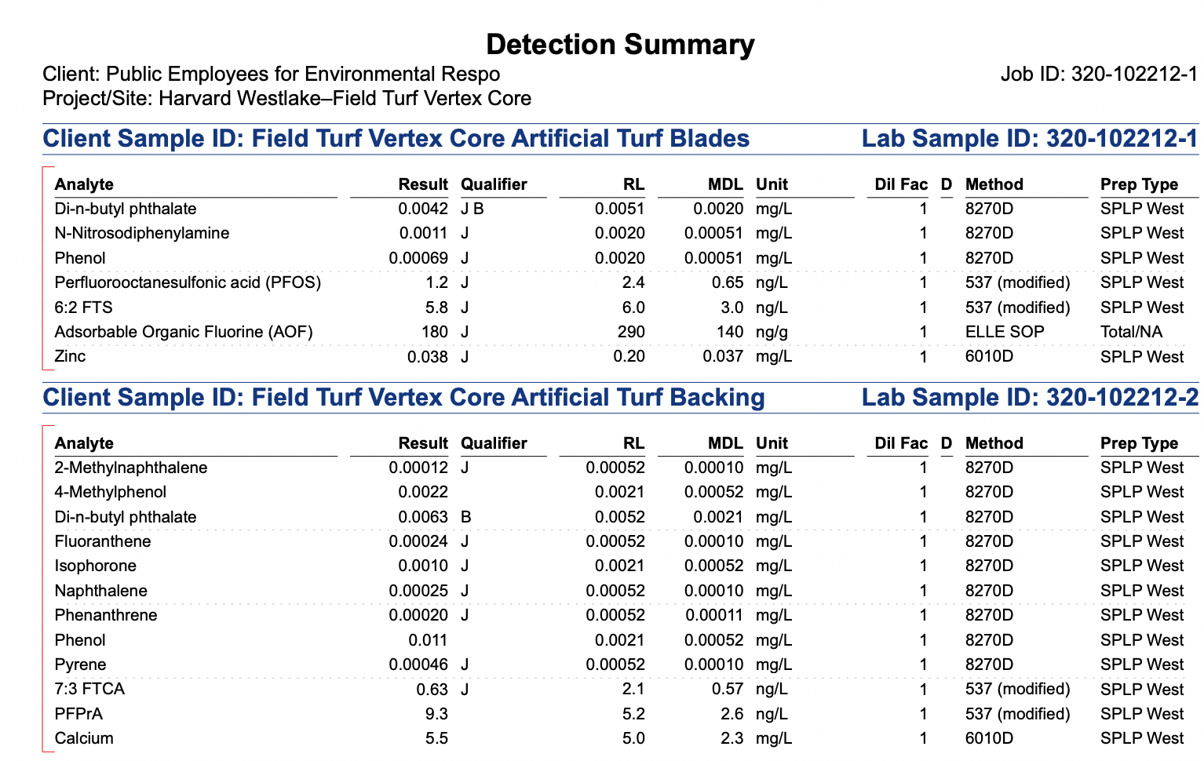

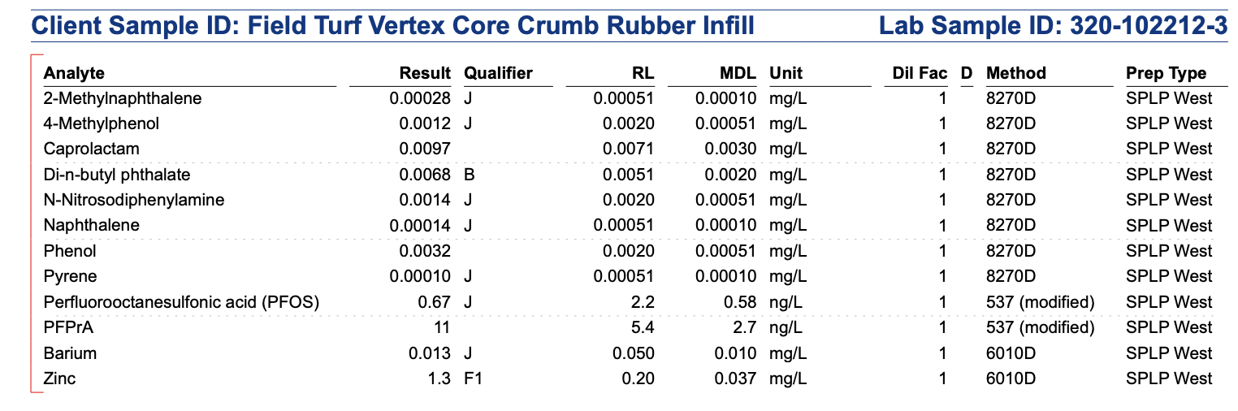

PEER used a Synthetic Precipitation Leaching Procedure (SPLP) treatment, tested the artificial turf blades and the backing separately, and also tested the crumb rubber. The SPLP is not an “aggressive” test. It is EPA’s standard procedure to determine what chemicals will leach off given their exposure to real life conditions, such as ultraviolet (UV) light, acidic rain, and abrasion.

PEER found perfluorooctanesulfonic acid (PFOS) in the artificial turf blades and in the crumb rubber infill (see Figure 2).

Figure 2
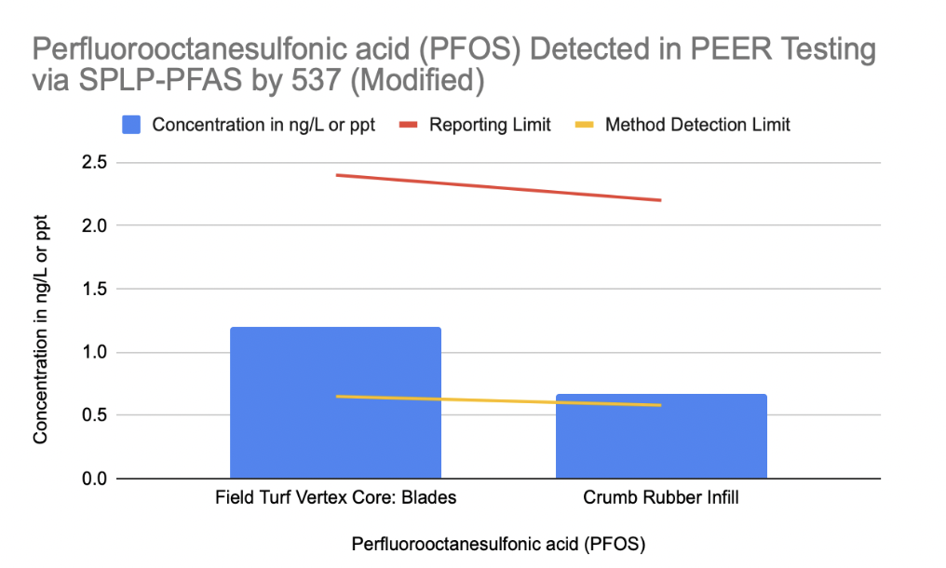

PFOS is one of the most well-known and dangerous PFAS. In June of 2023, the U.S. Environmental Protection Agency (EPA) issued proposed Maximum Contaminant Levels (MCLs) for six PFAS in drinking water, including PFOS. EPA stated, “EPA has determined that PFOA and PFOS are likely to cause cancer ( e.g., kidney and liver cancer) and that there is no dose below which either chemical is considered safe…” Those MCLs are expected to be finalized this summer or early fall. Therefore, any amount of PFOS in artificial turf is of grave concern.

PEER also found three (3) other PFAS in the artificial turf system proposed by Harvard-Westlake:

- perfluoropropionic acid (PFPrA) in the backing and infill;
- 6:2 fluorotelomer sulfonic acid (6:2 FTS) in the blades; and
- 7:3 fluorotelomer carboxylic acid (7:3 FTCA) in the backing.

Harvard-Westlake’s results. The laboratory analyses conducted by Eurofins for PEER differed from the laboratory methods conducted by Eurofins for Harvard-Westlake’s consultant, David Teter. Mr. Teter asked the lab to measure the PFAS found in the turf and backing (mixed together) using EPA Method 537 (modified) in water; crumb rubber was not tested. This test will show which PFAS are present in the turf and backing. Mr. Teter’s results are graphed and shown in Figure 3.

Figure 3
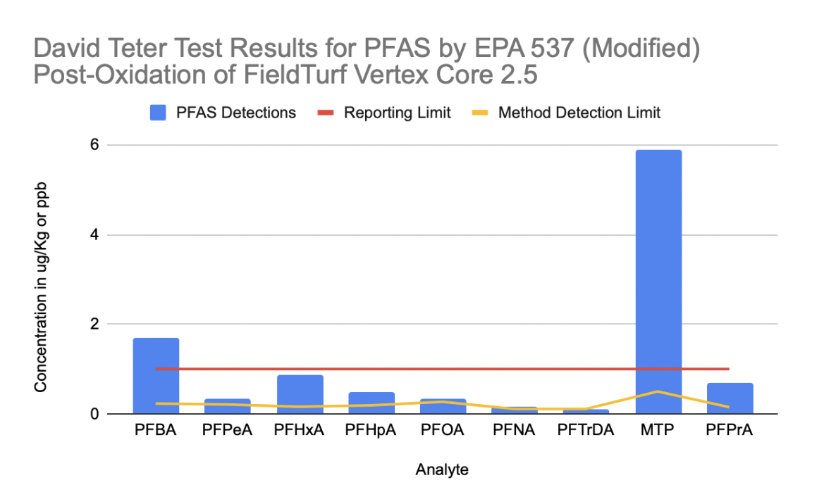

Mr. Teter’s results are presented in parts per billion (ppb). He found nine (9) PFAS in the blades and backing using post-oxidation tests., As the turf field ages and is exposed to the elements, these PFAS could leach into the surrounding environment.

Comparison of results. Figure 4 summarizes the differences between Mr. Teter’s testing and PEER’s testing. Between the two tests, a total of fourteen (14) PFAS were found. It is important to note that these are the results of targeted PFAS testing. Labs are only able to identify roughly 70 PFAS species out of the more than 12,000 PFAS in existence. Some of these PFAS that cannot be tested for can yield terminal end products that are PFAS of great concern for human health and the environment, such as PFOA and PFOS.

Figure 4

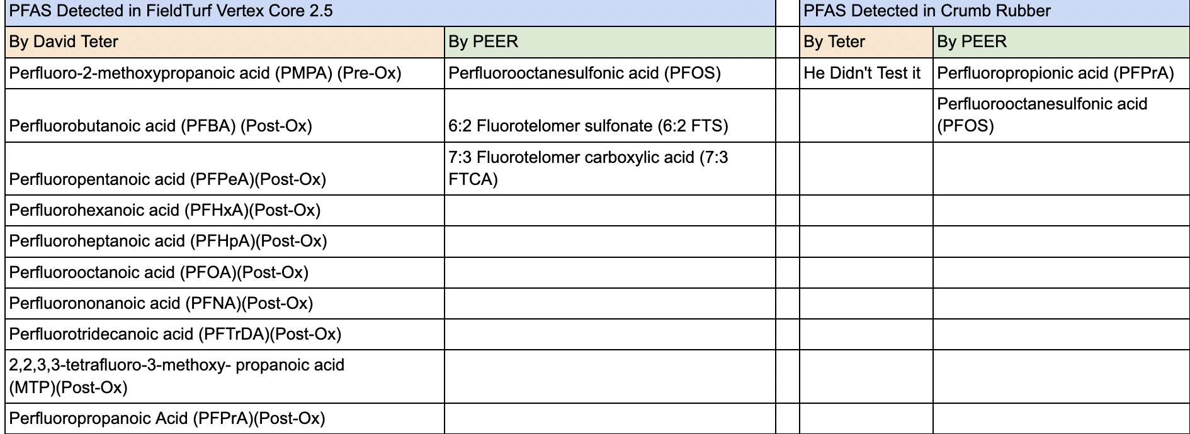

PEER found four (4) PFAS in the turf components, and Mr. Teter found ten (10). While all PFAS are of toxicological concern due to their persistence alone, it is particularly disturbing to find PFOA and PFOS in these artificial turf field components. As stated above, EPA has determined there is no safe dose of these PFAS.

Conclusion. The artificial turf proposed by Harvard-Westlake does contain PFAS, including two PFAS that are of critical concern, PFOA and PFOS. Indeed, the industry now acknowledges that all artificial turf contains PFAS. A bill proposing to ban artificial turf containing PFAS in California led to the Synthetic Turf Council testifying that:

The bill a (sic) ban on the sale of artificial turf containing intentionally added PFAS on January 1, 2024 to certain public entities and by January 1, 2025 for all sales in California. These dates do not provide enough time for manufacturers and suppliers to develop viable alternatives for the market place…

If Harvard-Westlake is given approval to use artificial turf for this project, these PFAS will contaminate the soil and waters around the project site, and expose both the athletes and others using the fields to these carcinogenic chemicals.

https://www.federalregister.gov/documents/2023/03/29/2023-05471/pfas-national-primary-drinking-water-regulation-rulemaking#addresses
Note that all values that fall between the yellow line (the Method Detection Limit, or MDL), and the red line (the Reporting Limit, or RL) will be “J” flagged by labs. This does not mean that the level is too low to be confident that the PFAS is present; according to the US. Environmental Protection Agency, anything above the MDL means that they are 99% confident that the PFAS is present in the sample.
Mr. Teter also found a tenth PFAS, Perfluoro-2-methoxypropanoic acid (PMPA), in a pre-oxidation test, but we have not provided that graph here.
June 21, 2023 letter from Melanie Taylor, President & CEO, Synthetic Turf Council to California Senator Ben Allen; copy available upon request

