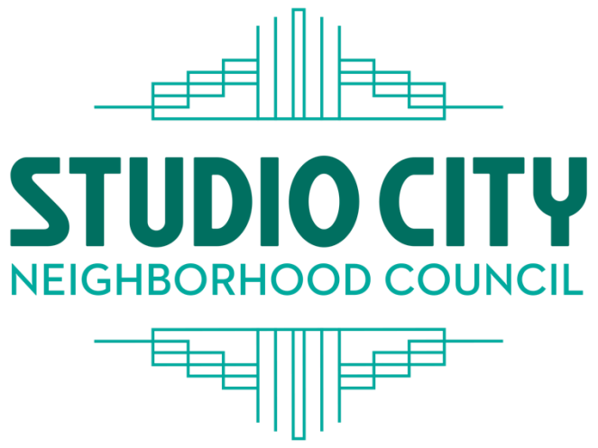
LEGALLY REQUIRED OFFICIAL POSTING – PLEASE DO NOT REMOVE UNTIL AFTER BELOW DATE AND TIME

SCNC BOARD
PRESIDENT
Richard Adams Randall Fried
Brian Carroll
Michael De Lazzer
Randall Fried VICE PRESIDENT Alex Izbicki Nancy Kremer
Mira Kaplan
Reduca Kaplan
Lisa Karadjian
Nancy Kremer TRESURER
Richard Niederberg Rick Rosner
Jesse Porter
Rick Rosner SECRETARY
Lana Shackleford Alexa Steinberg Alexa Steinberg
Adam Summer
Joseph Tichy CORESPONDING SECRETARY
Michael De Lazzer

Virtual CULTURAL AFFAIRS COMMITTEE MEETING
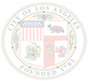
Tuesday May 4, 2021 - 7:00 PM

Zoom Meeting Online or By Telephone
https://zoom.us/j/93281998153
Meeting ID: 93281998153

Or dial 669-900-6833 to Join the Meeting Then Enter This Webinar ID: 93281998153 and Press #

Committee Members: Richard Niederberg, Board Member (Chair). Mary Mallory (Vice Chair and Secretary, Stakeholder) Rick Rosner, (Board Member), Barry Johnson (Stakeholder), Chief Joseph de Jesus de Luna (Stakeholder), Alex Naseef (Stakeholder), Randy Fried (ex-offico)
- Call to Order and Roll Call

- Public Comments

- Next Event: May 20, 2021 @ 7pm –
‘Master Architects of Southern California 1920 – 1940’
The work of Paul Williams is featured.
Presenter: Stephen Gee Presented in conjunction with the Studio City Library
Mary Mallory, SCNC organizer and Host
- Presentations by authors of books entitled:
‘Ink and Paint - Women of Disney Animation’, ‘Ladies of the Black Lagoon’, and ‘Hollywood Chinese’ as future Cultural Affairs Committee presentations?
5. Suggestions for future events
6. Public Comments on Non-Agenda Items within the Board’s jurisdiction.
7. Adjournment

2 3
Studio City Neighborhood Council Committee Meeting Agendas are posted for public review on the SCNC website at studiocitync.org and at the CBS Studio Center Radford and Colfax gates.
VIRTUAL MEETING TELECONFERENCING NUMBER FOR PUBLIC PARTICIPATION
In conformity with the Governor’s Executive Order N-29-20 (MARCH 17, 2020) and due to concerns over COVID-19, the Studio City Neighborhood Council meeting will be conducted entirely telephonically.
Every person wishing to address the Neighborhood Council must dial 669-900-6833, and enter 93281998153 and then press # to join the meeting. Instructions on how to sign up for public comment will be given to listeners at the start of the meeting
GENERAL PUBLIC COMMENT ON NON AGENDA ITEMS
THE AMERICAN WITH DISABILITIES ACT - As a covered entity under Title II of the Americans with
Disabilities Act, the City of Los Angeles does not discriminate on the basis of disability and, upon request, will provide reasonable accommodation to ensure equal access to its programs, services, and activities. Sign language interpreters, assistive listening devices, and other auxiliary aids and/or services, may be provided upon request. To ensure availability of services, please make your request at least 3 business days (72 hours) prior to the meeting you wish to attend by contacting the Department of Neighborhood Empowerment by email: NCSupport@lacity.org or phone: (213) 978-1551.
PUBLIC ACCESS OF RECORDS – In compliance with Government Code section 54957.5, non-exempt writings that are distributed to a majority or all of the board in advance of a meeting may be viewed at 4024 Radford Ave. Editorial Bldg. 2, Room 6. Studio City, CA 91604 and at our website: www.studiocitync.org or at the scheduled meeting. In addition, if you would like a copy of any record related to an item on the agenda, please contact Randall Fried by email at: rfried@studiocitync.org
PUBLIC INPUT AT NEIGHBORHOOD COUNCIL MEETINGS – The public is requested to dial *9, when prompted by the presiding officer, to address the Board on any agenda item before the Board takes an action on an item. Comments from the public on agenda items will be heard only when the respective item is being considered. Comments from the public on other matters not appearing on the agenda that are within the Board’s jurisdiction will be heard during the General Public Comment period. Please note that under the
Brown Act, the Board is prevented from acting on a matter that you bring to its attention during the General Public Comment period; however, the issue raised by a member of the public may become the subject of a future Board meeting. Public comment is limited to 2 minutes per speaker, unless adjusted by the presiding officer of the Board. PUBLIC POSTING OF AGENDAS – Neighborhood Council agendas are posted for public review as follows:
CBS Studio Center outside the Radford and Colfax gates.
http://www.studiocitync.org/
•
•

